**Unit 6: Transformations**

Lesson 2: Stretches, compressions and flips

Objectives:

* I can identify parent functions
* I can identify different types of transformations
* I can graph transformed functions

Agenda:

* Use your skills
* Use all your skills
* Challenge your skills

Vocabulary:

* Function, parent function, transformed function, stretch, compressions, flip.

Focus Questions:

1. How do we describe the difference between the graphs of any function and its parent function?

Online support:

[www.khanacademy.org/math/algebra2/manipulating-functions/stretching-functions/v/compressing-functions-example](http://www.khanacademy.org/math/algebra2/manipulating-functions/stretching-functions/v/compressing-functions-example)

[www.youtube.com/watch?v=7S5HF38DnUY](http://www.youtube.com/watch?v=7S5HF38DnUY)

Online Practice:

[www.mathsisfun.com/sets/function-transformations.html](http://www.mathsisfun.com/sets/function-transformations.html)

Homework: Finish the practice and Study for Midterm

B

C

**Do Now:**

**Midterm review:**

1. Mike goes to a bakery and buys four cookies and three drinks for a total of $5.30, and Anna goes to the same bakery and buys six cookies and 2 drinks for a total of $6.20 . How much does one cookie cost and how much does one drink cost? Only an algebraic solution will be accepted.
2. Find the rate of change from the given two points. (2,3) and (4,4) then write an equation of the line in the slope-intercept form.
3. Find the domain and the range of the function on the right;



1. Which representations are functions?

|  |  |  |  |
| --- | --- | --- | --- |
| I.  https://www.castlelearning.com/Review/Courses/math/q135976-1.gif?v=20151216032834 | II.  {(1, 1), (2, 1),  (3, 2), (4, 3),  (5, 5), (6, 8),  (7, 13)} | III.  https://www.castlelearning.com/Review/Courses/math/q135976-3.gif?v=20151216032834 | IV. |

1. I and II 2. II and IV 3. III, only 4. IV, only



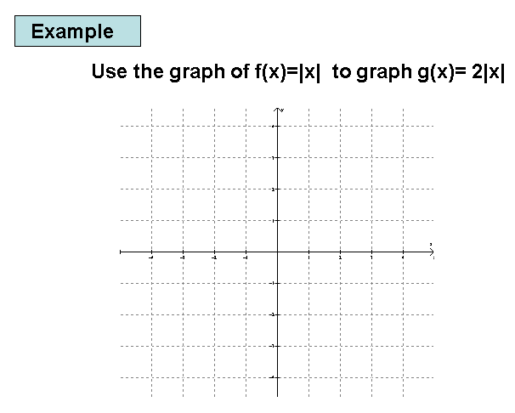Use the calculator to fill in the table and graph $f\left(x\right)=\sqrt{x }and h\left(x\right)=-\sqrt{x}$

|  |  |
| --- | --- |
| x | f(x) |
| 0 |  |
| 1 |  |
| 4 |  |
| 9 |  |
| 16 |  |

|  |  |
| --- | --- |
| x | h(x) |
| 0 |  |
| 1 |  |
| 4 |  |
| 9 |  |
| 16 |  |

Observation:

Use the calculator to fill in the table and graph $f\left(x\right)=\sqrt{x }and g\left(x\right)=\sqrt{-x}$

|  |  |
| --- | --- |
| x | f(x) |
| 0 |  |
| 1 |  |
| 4 |  |
| 9 |  |
| 16 |  |

|  |  |
| --- | --- |
| x | g(x) |
|  |  |
|  |  |
|  |  |
|  |  |
|  |  |

Observation:

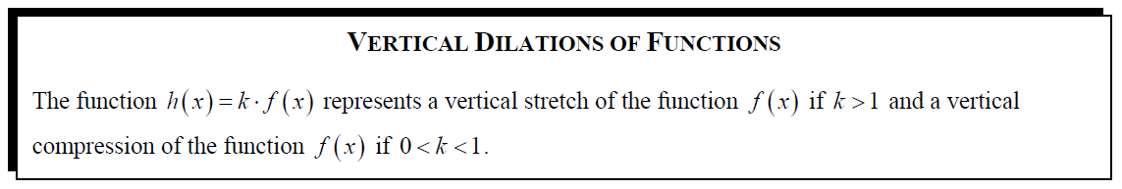

Use the calculator to fill in the table and graph $f\left(x\right)=|x|$ and $g\left(x\right)=2|x|$.(x,y) becomes (x, 2y)

|  |  |
| --- | --- |
| $$x$$ | $$g(x)$$ |
| **-3** |  |
| **-2** |  |
| **-1** |  |
| **0** |  |
| **1** |  |
| **2** |  |
| **3** |  |

|  |  |
| --- | --- |
|  |  |
| **-3** |  |
| **-2** |  |
| **-1** |  |
| **0** |  |
| **1** |  |
| **2** |  |
| **3** |  |

Observation:

Use the calculator to fill in the table and graph $f\left(x\right)=|x|$ and $g\left(x\right)=1/4|x|$.

|  |  |
| --- | --- |
| $$x$$ | $$g(x)$$ |
|  |  |
|  |  |
|  |  |
| **0** |  |
|  |  |
|  |  |
|  |  |

|  |  |
| --- | --- |
|  |  |
| **-6** |  |
| **-2** |  |
| **-1** |  |
| **0** |  |
| **1** |  |
| **2** |  |
| **4** |  |

Observation:

**Extended practice: 6-2: Transformations**

**Sketch the following transformations from f(x). Use the Function Transformation word bank to describe the transformation that changed the parent function f(x) to the transformed functions**

Parent Function: Exponential function $f\left(x\right)=2^{x}$

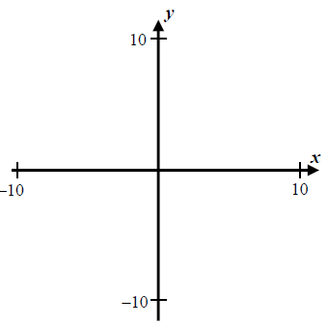

$A) t\left(x\right)=-2^{x}$

$$B) z\left(x\right)=3{(2)}^{x}$$

$$C) h\left(x\right)=\frac{1}{3}({2)}^{x}$$

$$D) g\left(x\right)=-2^{x}+3$$